October 2015

Blessings

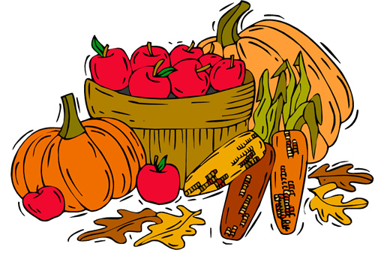

Rossford United Methodist Church

270 Dixie Hwy

Rossford, OH 43460

Phone:

(419) 666-5323

**Office Hours:**

M-F 8:00am-2:00pm

Facebook:

www.facebook.com/RossfordUMC

E-Mail:

rossfordumc@yahoo.com

Visit us at:

[www.rossfordumc.org](http://www.widgets.msn.com/)

**Services**

9:00 am Sunday School (All ages)

10:30 am Worship Service



**A Day of Prayer and Fasting**

Karl Barth, a Swiss theologian from the 20th. century had this to say about prayer: “To clasp the hands in prayer is the beginning of an uprising against the disorder of the world.” It doesn't take much imagination for us to realize that our world is in utter disorder. Jesus said to the father of a young boy whose life was in great disorder from a demon of convulsion that “this kind will only come out by much prayer and fasting.” Bishop Palmer has invited all of the West Ohio Conference United Methodist brothers and sister to participate in a day of prayer and fasting each month between now and the General Conference which will be held in May 2016. The suggested day is the first Friday of each month. Here are some general reminders about fasting.

• Following the Wesleyan pattern, fasting would ideally begin following the evening meal on Thursday evening and continue until the fast is broken with the evening meal on Friday.

• Your abstinence or fasting from food should be done in consultation with your medical practitioners and your own bodily needs. Not all can abstain from food but all can pray.

• You are encouraged to spend intentional time in prayer from Thursday evening to early Friday evening. As you are able, devote some time to private prayer and to prayer in community (a prayer partner, small groups etc).

• In general our prayers should focus on world event and the well-being of the church and the mission of the church. We will be seeking the heart of God to renew the heart of the church.

• You may want to consider donating the money saved by fasting from food to some mission initiative in the life of our church or conference.

You may choose a different day if it fits better in your schedule. The idea is to have as many of us as will to be in prayer together.

Grace and Peace,

Pastor Bob Ball

Rossford United Methodist Church

Our Mission: To Know Christ And to Make Christ Known

Inside This Issue:

Pastor's Pen 1

Dock & Worship News 2

How Can You Help? 3

Music and Bell Choir 3

Celebrations 4

Calendar of Events 5/6

Fundraising, Fellowship 6



The Dance of Life

**"A Journey with Scripture and Music"**

**To be presented by the**

**Rossford United Methodist Choir**

**Sunday morning, October 25, 2015**

**(In Memory of Bernice Baughman)**

One of Bernice’s favorite hymns is “The Lord of the Dance.” Written by Sydney Carter, this classic hymn is a metaphor of the life of Christ and those who choose to follow him.

In beautiful, poetic language, Carter describes Jesus as “The Piper” calling his followers to the dance of life with him. This journey with scripture and music is an elaboration on that hymn, portraying each verse individually in a dramatic and colorful presentation - all retelling the story from John 3:16, “For God so loved the world that he gave his only Son, so that everyone who believes in him may not perish but have eternal life.”

Retelling the story of the life, death and resurrection of Jesus in the central theme of the Bible and is the primary story that the church has to offer the world today. The story of Jesus when heard by heart transforms the life of the individual and the world itself. It is “The Greatest Story Ever Told” and needs to be shared in dramatic ways that will catch the heart of the hearer.

Please plan to be present on October 25 and invite someone to come with you.

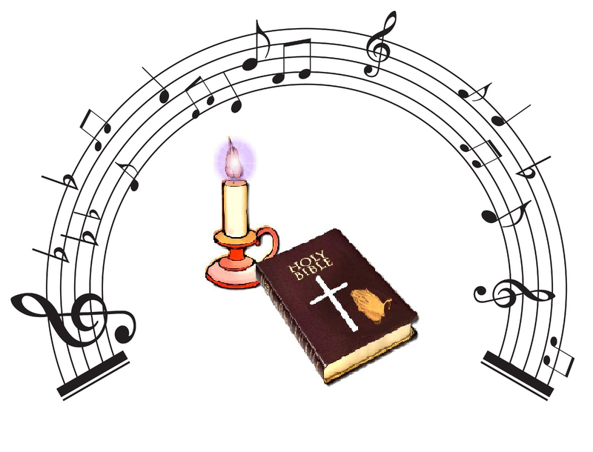

**DOCK News**

We’re off to a great start to our DOCK year. We worked Rally Day, started confirmation classes and had our first DOCK meeting. By the time you read this we will have led worship on Sept. 27th with the theme of “You Are God’s Masterpiece”.

October will be a busy month for the youth. We will be joining the adult choir on World Communion Sunday, Oct. 4th to sing “He Reigns”. Following worship we’ll be running the drive-thru for the Chicken BBQ. Any tips we earn will go toward our youth activities. We’ll have pizza at 2:00 and confirmation class at 3:00. DOCK will not meet in the evening.

I will be out of town on Sunday, October 18th so there will be no DOCK that night. Confirmation class will begin at 4:00, as usual. The youth group will not be leading worship on October 25th. There will be a cantata performed by the choir that Sunday.

DOCK will be building a float for the Rossford Halloween Parade. The parade is Sunday the 25th so we’ll have lunch upstairs after church and then head to the judging at 1:00. The parade begins at 2:00. We’ll need lots of candy so start collecting!

DOCK will be hosting another Talent Show this year. “RUMC: Under the Big Top” will be on November 1st. Plan on attending and/or performing!!!

If you know of any youth in grades 5- 12 who would be interested in joining DOCK please let me know or just send them upstairs on a Sunday night. We meet from 5:00 – 7:00 and we’re a fun and welcoming group.

Terri Seibold

Director of Youth Ministry

Page 2

**Worship News**

Thanks all the musicians who made Rally Day Service special. A combination of our choir, piano, and youth with instrumentation made for a great service. Upcoming events to mention are below

October 4th - Worldwide Communion Sunday as well as the date for our Chicken Barbeque.

October 18th - Guest speaker in the pulpit, Rev. Larry Keeler

October 24th - "Dance of Life: A Journey with Scripture and Music"



**Box Tops, Campbell's, Stamps**

Thank you for all your help with the stamps. We are still collecting Box Tops for Education, Campbell's soup labels and cancelled stamps. The boxes are located in the Narthex. Please see Barb Chesson if you have any questions.

**Can Drive**

We would like to remind you that we are still collecting cans to raise money for our church. If you have any to donate, the container is outside the kitchen door. If you need a pickup, please call Doug Williams at 419-661-9484.

**Counters needed for 2016**

The Finance Committee is looking for volunteers to help count tithes on Sundays in 2016. It usually takes 1 hour after services, and training will be provided. Please see Larry Ulrich if you are interested.

**UMC Market**

The United Methodist Church has started a "market." This is a way for our church to earn money. You need to go online to [www.umcmarket.org](http://www.umcmarket.org) and sign up. Whenever you order from this site our church receives a % of what you purchase. There are 89 pages of participating stores and the amount we receive varies. Any questions, see Sue Perkins.

**Kroger Store**

If you have a Kroger card, PLEASE make sure you are signed up so that our church gets a percentage of what you buy.  This is "Free" money for our church.  You MUST sign up EACH YEAR so our church gets credit for what you buy.  Any questions, see Sue Perkins.

**Prayer Quilts**

If you know of anyone who would benefit from a prayer quilt please call or see Nancy Stonerock. She can be reached at

419-874-3504.

**Rehearsals**

Bell Choir will hold regular Thursday

evening practices at 6:00pm.

Choir will rehearse Thursday evenings at 7:00pm.

**Helping Hands of St. Louis**

Please contact Jerry Baumgartner at 419-666-7236. The next dates are 11/5 and 12/17.

**Ushers and Greeters**

Please see Bob Baughman to Usher or Betty Dowell or Brenda and Al Weis to Greet.

**Hospitality**

After most services we offer coffee and snacks. We love to have something yummy in our tummies, but that will only happen if people will sign up or donate goodies to serve. Please consider this ministry.

Thank you,

Brenda and Al Weis, Hospitality and Congregational Care Co-Chairs

**Lost and Found**

We have a lost and found in the church office. If you have lost anything, please check here as we have many items that are missing their owners.

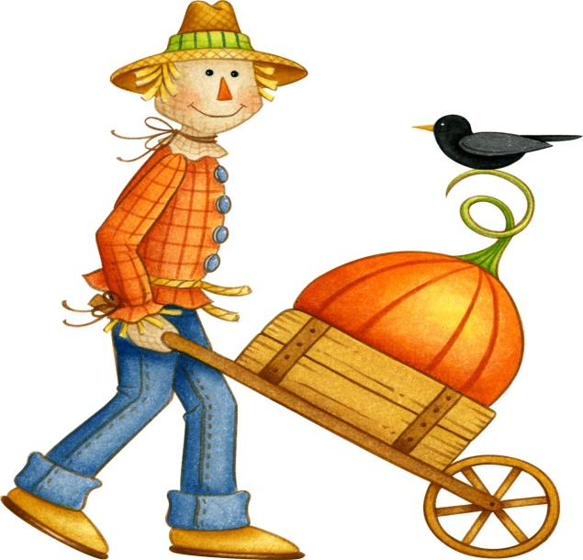

Page 3

**October Celebrations and Thanks**

**Anniversaries**

John III & Bethany Rust 10/2

Ken & Jenny Boggs 10/6

Jim & Judy Sikorski 10/20

Bill & Jenny Graffius 10/27

**Birthdays**

Thomas Ball 10/1

Betty Woods 10/1

Brian Hollabaugh 10/4

Andrew Cuprys 10/6

Paul Pertner 10/6

Nancy Stonerock 10/6

Dave Olwick 10/8

Kim Stoffel 10/9

Steven Fawcett 10/11

Evan Flinn 10/11

Sue Thompson 10/11

Jack Engwert 10/12

Debbie James 10/12

Sarah Buehrer 10/13

Dale Jacoby 10/16

Andrew Thompson 10/23

Mary Ashley 10/25

Cameron Agler 10/26

Tanya Henninger 10/27

Kim Weyandt 10/27

Lindsay Brant 10/30

Wendell James 10/30

Billy Graffius IV 10/31

Joe Thompson 10/31



**On the lighter side, a little humor for you…**

A very upset minister walked into the fish market. "I want you to throw me four big fish," he said to the clerk. "Just toss 'em to me."

"But why toss them to you?" the fishmonger asked. "Can't I just wrap them and give them to you like everyone else?"

"No Sir!" yelled the preacher. "Do just as I say. So if anyone asks me if I caught any fish today, I can truthfully say, 'Sure did. Caught four big ones!' "



Page 4

|  |  |
| --- | --- |
| caramel apples.png | |
|  |  |
| http://thumbs.dreamstime.com/t/october-clip-art-whimsical-cartoon-text-doodle-month-44872805.jpg | |
|  |  |
|  | |

|  |  |  |  |  |  |  |
| --- | --- | --- | --- | --- | --- | --- |
| *Sun.* | *Mon.* | *Tue.* | *Wed.* | *Thu.* | *Fri.* | *Sat.* |
|  |  |  |  | 1 | 2 | 3 |
|  |  |  |  | Chicken BBQ Setup  6:00pm Bells  7:00pm Choir  8:30pm AA | Chicken BBQ Setup | Chicken BBQ Setup |
| 4 | 5 | 6 | 7 | 8 | 9 | 10 |
| 9:00 am Sunday School  10:30am Worship  11:30am BBQ  3:00-4:00pm Confirmation Class #3  NO DOCK | 6:30pm Women's Bible Study  6:30pm Cardio Drumming | 9:15am Women's Bible Study  6:30pm Cub Scouts | 6:30pm Boy Scouts  6:30pm Cardio Drumming | 6:00pm Bells  7:00pm Choir  8:30pm AA |  | 9:00am Men's Breakfast at  795 Diner  7:00pm Contra Dance |
| 11 | 12 | 13 | 14 | 15 | 16 | 17 |
| 9:00 am Sunday School  10:30am Worship  4:00-5:00pm Confirmation Class #4  5:00pm DOCK | 6:30pm Women's Bible Study  6:30pm Cardio Drumming | 9:15am Women's Bible Study  6:30pm Cub Scouts  6:00pm Hospitality  6:30pm SPRC, Finance, Trustees  7:30pm Admin | 6:30pm Boy Scouts  6:30pm Cardio Drumming | 6:00pm Bells  7:00pm Choir  8:30pm AA |  |  |
| 18 | 19 | 20 | 21 | 22 | 23 | 24 |
| 9:00 am Sunday School  10:30am Worship  4:00-5:00pm Confirmation Class #5  NO DOCK | 6:30pm Women's Bible Study  6:30pm Cardio Drumming | 9:15am Women's Bible Study  6:30pm Cub Scouts | 6:30pm Boy Scouts  6:30pm Cardio Drumming | 6:00pm Bells  7:00pm Choir  8:30pm AA |  | Building Float for Rossford Parade |
| 25 | 26 | 27 | 28 | 29 | 30 | 31 |
| 9:00 am Sunday School  10:30am Worship  1:00pm Rossford Parade  5:00pm Trunk or Treat | 6:30pm Cardio Drumming | 9:15am Women's Bible Study  6:30pm Cub Scouts | 6:30pm Boy Scouts  6:30pm Cardio Drumming |  |  |  |

**Fall Chicken BBQ**

Our Fall Chicken BBQ will held on Sunday, October 4th. We need help on Friday the 2nd, Saturday the 3rd, and of course on Sunday the 4th. Set up starting Sept. 30th. Mark your calendars. Questions see Sue Perkins.

**Annual Christmas Craft Bazaar and Homemade Luncheon**

Mark your calendars now for our annual Christmas Craft Bazaar and Homemade luncheon, Saturday November 14th from 10:00am-4:00pm. Set up starting Nov. 8th. We will need helpers for our bade sale, opportunity Drawing Table, Church Sale Table, and the Luncheon. Signup sheets will be up at the end of October. Please help us by donating a couple of hours or even a baked good or two. Come help and get some Christmas shopping done to support our local crafters.

Thank you - Nancy Rust



On Sunday October 25th at 5:00 pm, we are having a Trunk or Treat. If you would like to decorate your trunk and participate in the handing out of candy, please see Kim Weyandt at 419-266-9091. We would love to have you. There is even a prize for best decorated trunk!

**Fall BBQ**

*Sunday, October 4*

**Dance of Life, Rossford Halloween Parade and Trunk or Treat**

*Sunday, October 25th*

**Talent Show "RUMC Under the Big Top"**

*Sunday, November 1st*

**Apple Dumplings**

*November 6th and 7th*

*For sale on November 8th*

**Craft Bazaar**

*Saturday, Nov. 14th*

*10:00 am to 4:00 pm*

**Contra Dancers**

*Saturday, November 14 and December 12th from 7:00 pm to 11:00 pm.*

**Cardio Drumming at RUMC**

"It's a Lifestyle Nutrition" (a new Rossford business at 325 Dixie Hwy!) presents Cardio Drumming. Classes will be on Monday's and Wednesday's from 6:30-7:30 in the FLC and are only $2. All skill levels are welcome. Contact Kelly Jo Dorn for more information at 419-276-0412 or check her out on Facebook at "It's a Lifestyle Nutrition". Walk-in's are welcome. Classes are held in the Family Life Center.

**Talent Show 2015**

The youth group will be hosting our 3rd Annual RUMC Talent Show. This year’s theme is “RUMC: Under the Big Top”. It’s scheduled for Sunday, November 1st. We will be having a potluck immediately after church followed by the show. **Without you we have no show** so please start thinking about what you can share! Let’s make it a show to remember. Sign-up in the Narthex or just let me know what you want to do. Friends, grandchildren, neighbors are all welcome to attend and/or perform. We’ll make room for everyone! Write it on your calendars NOW!!!

Page 6



NON-PROFIT

US POSTAGE

PAID

TOLEDO, OH

PERMIT #522

ROSSFORD UNITED METHODIST CHURCH

270 DIXIE HWY

ROSSFORD, OH 43460

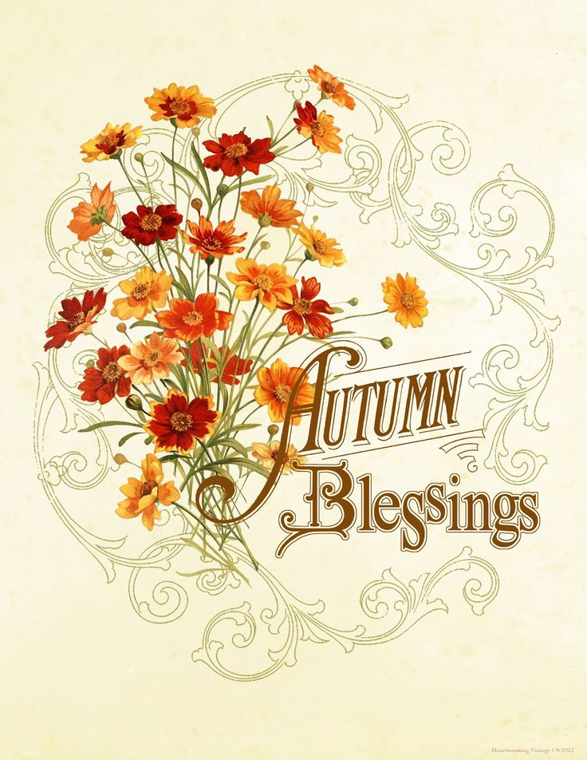

Staff

Pastor: Rev. Dr. Robert Ball

Ministers: Every Member

Children’s Ministry: Kim Weyandt

Youth Ministry: Terri Seibold

Secretary: Jenny Graffius

Music Program Director: Sarah Buehrer

Organist: JeanE Waggoner

Custodians: Steve Agler

Jenny Riehm

Nursery: Kaitlin Moore

Lay Leadership

Lay Leader: Tom Ridenour

Head Usher: Bob Baughman

Media Directors: Troy Westfall

Jeff Comley