July and August 2019

Greetings Church,
On July 21st, we, RUMC, will be celebrating our 120th year in ministry. RUMC has been serving our community, helping people here and around the world, sharing the love and grace of Jesus Christ, engaging in passionate worship, growing in our faith, participating in risk taking mission, offering radical hospitality, and generously giving of our time, energy, prayers, talents, and finances for 120 years. 120 years! God, through Jesus Christ and the Holy Spirit, has been working in and through us to bring love and grace and hope to our world. Through this power and presence of God we have seen people healed, relationships pieced back together, hope restored, faith ignited and reignited, lives changed and transformed, sins forgiven and people set free from the hurts and wounds of the past. We have experienced the presence of God, and have seen God do miracles in our midst.
Over these 120 years, we have experienced mountain top moments in which God is as close as our next breath doing amazing things in and through us. We have also experienced the valleys, the hurts and struggles of being the church together and wondering if we will survive another year. And yet in all this time, God has been faithful. God has been with us. God has, and is still, inspiring us to continue to do our best to offer hope and help, love and grace, prayers and connection, joy and friendship.
This is what Charles Wesley, one of the founders of the United Methodist Church along with his brother John, was getting at when he wrote the hymn O For A Thousand Tongues To Sing. He wrote this hymn in response to all that God had done for him and others and all the world. All the joy and beauty and grace and love that God had showered down upon Charles and everybody and everything, caused Charles to wish he had not one tongue but a thousand tongues to praise God for all his goodness. God has done so much for us and in us and through us as individuals and as a church that we too can sing with Charles Wesley:
"O for a thousand tongues to sing my great Redeemer's praise, the glories of my God and King, the triumphs of his grace!"
May we as one church, with one voice, and with the one foundation of Jesus Christ sing, tell, and live out the triumphs of God's grace. Let us celebrate and give thanks for God the Father, God the Son and God the Holy Spirit who loves us beyond our wildest imaginations, and sends us out into the world to be His people and His church to love and help and care for others. May we continue the great tradition that has been laid down by those who have come before us, or as the Bible describes them in the book of Hebrews, the great cloud of witnesses that surround us. May we love and live so that others will know that God is here with us still and will be with us always.
Grace and Peace,
Pastor Dwayne

UPCOMING SERMON SERIES

7/7 - "Final Instructions" 1 Thessalonians 5:12-28 Communion

New Sermon Series July 14th to August 25th
Our Faith in Hymns
7/14 – O For A Thousand Tongues To Sing
Luke 5:12-16
7/21 – The Church's One Foundation 120 Year Anniversary
1 Peter 2:4-12
7/28 – Amazing Grace VBS/Youth Sunday
Ephesians 2:1-10
8/4 – A Mighty Fortress Is Our God Communion
Romans 8:31-39
8/11 – Ask Ye What Great Thing I Know
Colossians 1:15-23
8/18 – Come Thou Fount Of Every Blessing
Luke 15: 1-7
8/25 – Tis So Sweet To Trust In Jesus Youth Sunday
Mark 6: 30-44

DOCK
Several of the youth gathered to help Tammy Miller clean up her yard. A special thank you goes out to Jeff Comley who joined us and kept the “gardeners” in line!!! We enjoyed a meal together at Cinco de Mayo afterward. It always feels good to lend a helping hand when we can.
VBS…The youth will be helping with VBS on July 22 – 25. We always have fun with the children, especially when we get the water balloons out! We’ll head to Dawgs for ice cream after each session if the weather permits. On the evening of the 26th there will be a VBS movie night. I’ve volunteered any available youth to help pop and bag popcorn to give to the movie-goers. We’ll enjoy the movie as well. We will lead worship on the 28th using the VBS theme and music.
Lock-In…I’d like to have our Lock-In on Saturday, Aug. 24th and then lead worship on the 25th. I like to kick off the new school year with fun and games. We also have discussions on peer pressure, self-worth and how to live a Godly life within our world (school). Plans are in the making. If there are any brave souls who would like to chaperone, let me know!!! You might get a little sleep.
DATES TO REMEMBER…
July 22 – 25 VBS (5:30 – 8:30 p.m.)
July 28 Youth Led Worship (Meet at 9:00 a.m.)
Aug. 24 Lock-In
Aug. 25 Youth Led Worship (Meet at 9:00 a.m.)
Terri Seibold
Director of Youth Ministry

WORSHIP NEWS

The sub-committee of Cheryl Garlow, Darlene Limmer, Nancy Rust, and Jane Williams are currently working hard on the 120th Anniversary celebration called “The Church’s One Foundation,” to be held on July 18th, 19th, and 21st. We are concentrating on the Worship Service on July 21st. It will be a special time for all of us. Former pastors have been invited and unfortunately not all will be present but some are coming. Pastor Dwayne has a great sermon planned, a history of the church will be given, lots of music, and a great service overall. If you would like to wear your purple t-shirt to the service, Pastor has said it is appropriate for this occasion.
Nancy Stonerock is working on a beautiful quilted banner for all of us to sign that day. She happens to be on the Cradle Roll at RUMC, 1930, listed as Nancy Appt, one of our longest active members. We have other members from the 1930s and 40s who join her in that honor and we will find out who they are during the potluck.
Jane Williams is planning the potluck after the service on July 21st. You will find sign-up sheets for the potluck on the easel in the Narthex. The Church will provide the meat and drinks. Please bring a large dish or two. We hope to have a great crowd out for this celebration luncheon! If you have any questions, please contact either Cheryl, Darlene, Nancy, or Jane.
We are collecting loose change for the 120th anniversary celebration next month. We’d like to challenge each of you to donate 120 cents between now and July 21 to help fund the celebration. Thank you!
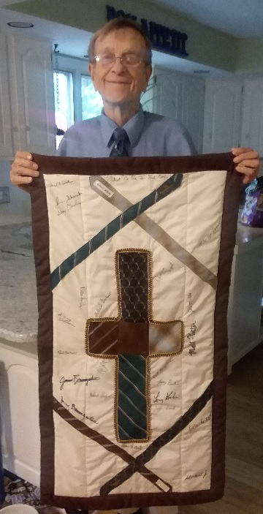
Beautiful purple shirts with our theme of the celebration, The Church’s One Foundation, are being sold through July 7 in the narthex. Proceeds from the t-shirts will help with our celebration. Cost is $10 per shirt and must be paid when your order is placed. For further information, contact Nancy Rust.

Thank you to Cheryl Garlow for making the Father’s Day banner which the men signed on June 16 and 23. She made a tablecloth back in 1994 for the ladies of the church to sign and we have set it out on Mother’s Day each year. It has become a part of the history of our church as many of the names written on it are former members who have passed away or moved away from this area. The men of the church now have the same piece of history as their quilt will be set out each year too! The quilt was made from men’s ties and is titled, “Blessed Be the Tie That Binds”
We are very excited about all three days of celebration!!! We hope you are too! You will be hearing lots more about this occasion.
Thank you,
Worship Committee

CAR RALLY
On Thursday, July 18th from 6 - 8 pm, we will be having a Car Rally in our parking lot. We will be selling food and will need help in the kitchen. It should be an exciting time. Cruzin Zeke is our organizer and will take care of getting cars. We will also have an area for children's activities. This event is also our "KICK OFF" to celebrate our church's 120 Anniversary.

FEEDING THE KIDS
Once again we will be doing the Feeding the Kids program during the months of June and July (Closed July 4th). Our hours for serving are 11:00 to 12:30. We need people to pick up the food about 10:00 and people to work in the kitchen from 10:30 to 1:00. There is a signup sheet in the Narthex. PLEASE take part in this project. It provides food to some children who might not get a meal during the summer. Any questions see Sue Perkins.
ICE CREAM SOCIAL
We will be having an Ice Cream Social on Friday July 19 to continue our 120th Church Anniversary!!!! Exciting times!! Plan on being a part of the whole weekend.
- Fall Rummage Sale - September 19 to 21 (Set up will be Sunday, September 8 to Wednesday, September 18)
- Fall BBQ - Sunday, October 6
- Christmas Craft Bazaar - Saturday, November 16th
As always volunteers make the event a success! Be on the lookout for sign up sheets for the above events. Or contact Sue Perkins with questions.

The 2019 Altar Flower schedule is out on the table in the Narthex.

Please consider signing up and honoring your loved ones with flowers.

Media Booth help needed

We are in need of some new and fresh faces in the Media Booth. If you are interested in working with media, or have any questions, please let Pastor Dwayne and or Kristen Vargo know. You can also call the office and let us know.

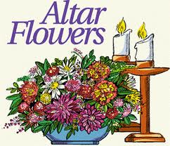

CHILDREN'S MINISTRY

Hi everyone! Sunday School continues to go well. The teachers we have are amazing. We've moved into the choir room in order to be closer to the nursery so that we can help each other out.
VBS is set for July 22nd - 25th from 5:30 - 8:00 pm. The theme is "God Is..." If you are interested in helping out please see me!
Thank you,
Kim Weyandt

CONGREGATIONAL CARE COMMITTEE

Our committee is just taking it easy and helping out with coffee hour, valet and greeter for the summer. We appreciate all who have volunteered to help out. This is an easy way to give your time and doesn't require any commitment except to show up a half hour before church starts. Please see Al or myself if this is something you'd like to do.
July valet: Al Weis
July greeter: Sherry Engwert
August valet: Your Name Here!!
August greeter: Kim Weyandt
Thank you and enjoy the rest of the summer,
Al and Brenda Weis and Kim Weyandt
Continuing Care Committee co-chairs

ANNIVERSARIES
Dan & Sarah Buehrer 7/11
Ray & Shirley McLargin 7/16
Pete & Evelyn Petersen 8/12
Paul & Janet Pertner 8/16
Larry & Kathy Ulrich 8/17
Doug & Jane Williams 8/30

***If we missed you or someone else, please let us know at rossfordumc@yahoo.com or
call 419-666-5323***

Doug Williams 8/5
Kim Loch 8/7
Jenny Graffius 8/11
Bill Garlow 8/15
Bob Baughman 8/16
Abigail Markin 8/16
Betty Dowell 8/22
Jane Williams 8/25
Judy Bowerman 8/26
Steve Agler 8/27
Marcia Olwick 8/30

BIRTHDAYS
Jamie Baumgartner 7/1
Diana Ruffalo 7/2
Jeff Loch 7/3
Larry Ulrich 7/9
Bill Bachar 7/18
Pat Baumgartner 7/20
Helen Shufritz 7/20
Ray McLargin 7/21
Jim Miller 7/21
Mary Hill 7/27
Avery Longnecker 7/27
Laura Arnold 7/28
Rox Ann Brewer 7/28

Thank You!

To the Church Youth Group,
I want to thank the Youth Group, Terri, and Jim for the wonderful job they did on my yard. I feel way blessed.
Love,
Tammy Miller
RED CROSS BLOOD DRIVE RESULTS:
Friday, June 21st, 2019
17 total units of blood donated!
Thank you for a great day!
Stephanie and Team at the American Red Cross of Northwest Ohio
Dear Members and Friends of Rossford UMC,
It is with a deep sense of pride and excitement that we write this letter of congratulation upon your celebration of 120 years of ministry and service of the community of Rossford. You have been faithful servants of the Kingdom of God following the traditions set by your ancestors who first established the Methodist community as God breathed into it the breath of life. There are wonderful stories in your historical records that share the love, life, struggles and victories over the past 120 years. You continue to pain the picture of faith in Christ holding it up for the children and the youth of today who will carry that tradition on into the future. We are honored that we had the opportunity to serve with you over a short portion of your full journey. Our prayers and love will be with you on the weekend that you celebrate.
Unfortunately, we will not be able to attend your anniversary celebrations. We had made a prior commitment to fly to Burlington, VT to celebrate Bobby's birthday which is July 19th. Being so far away from family means that we need to take every opportunity to travel there to create family memories.
Please know what we love you and are thrilled that you continue to hold the torch of Christ's love to your part of the world. You are making a significant difference that makes the world a little bit better. Celebrate big. Have fun, Enjoy the weekend. We will be thinking of you.
Love and Prayers,
Pastor Bob and Shirley Ball

HOW CAN YOU HELP OUT?

Ushers and Greeters
Please see Bob Baughman to Usher or Brenda and Al Weis to Greet or Valet.
Helping Hands of St. Louis
July 11th, 2019
Questions? Please contact Jerry Baumgartner at 419-666-7236.
Prayer Quilts
If you know of anyone who would benefit from a prayer quilt please call or see Nancy Stonerock. She can be reached at 419-874-3504.
No Longer Accepting Cancelled Stamps
We will no longer be collecting cancelled stamps. The
program has been discontinued. We appreciate all the
donations, and thank you to Barb Chesson for many years of help.
Can Drive
We would like to remind you that we are still collecting aluminum cans to raise money for our church. If you have any to donate, the container is outside the kitchen door. If you need a pickup, please call Doug Williams at 419-661-9484.
Kroger Rewards Program
Every purchase you make at your local Kroger could be helping the Rossford United Methodist Church.
Register your Kroger Plus Card today and Kroger will donate a percentage of your purchase to benefit us.
Best of all, the only cost is a few minutes of your time. Visit http://www.krogercommunityrewards.com/
Instructions: Register your Kroger Plus Card online at http://www.krogercommunityrewards.com/
- Click on Sign in/Register
- Click on Sign up today in the New Customer box
- Enter zip code, click on your favorite store, enter your email address, create a password and agree to the terms and conditions.
- You will get a message to check your email. Go to your email and click on the link within the email message.
- Click on My Account, log in and proceed to the next step.
- Click on Edit Kroger Community Rewards and input your Kroger Plus card number
- Update or confirm your information
- Enter Rossford United Methodist Church or select it from the list, click and confirm.
- Plus cards are available at the customer service desk at any Kroger Store.
- Currently Kroger requires participants to re-enroll each April.

Your purchases will benefit RUMC once you have registered your card. If you use your phone number at the register, call 877-576-7587 to get your plus card number. Thank you for registering and applying community rewards to RUMC.

SUN | MON | TUES | WED | THURS | FRI | SAT
 | 1 | 2 | 3 | 4 | 5 | 6
 | 8 - 10 pm HEMA (FLC) | 11-12:30 Feeding Kids (FLC) |  | Offices Closed
7 | 8 | 9 | 10 | 11 | 12 | 13
9:00 am Adult Sunday School  10:30 am Worship | 8 - 10 pm HEMA (FLC) | 11-12:30 Feeding Kids (FLC) |  | 11-12:30 Feeding Kids (FLC)  8:30 pm AA
14 | 15 | 16 | 17 | 18 | 19 | 20
9:00 am Adult Sunday School  10:30 am Worship | 8 - 10 pm HEMA (FLC)  VBS SET UP | 11-12:30 Feeding Kids (FLC)  VBS SET UP | 5:00 pm Private Party (FLC)  VBS SET UP | 11-12:30 Feeding Kids (FLC)  6 - 8 pm Car Rally (prkg lot)  8:30 pm AA  VBS SET UP | 6 - 8 pm Ice Cream Social  VBS SET UP | Anniversary Set up
21 | 22 | 23 | 24 | 25 | 26 | 27
9:00 am Adult Sunday School  10:30 am Worship  120th Birthday Celebration  Potluck following worship | 8 - 10 pm HEMA (FLC)  5:30 - 8 pm  VBS | 11-12:30 Feeding Kids (FLC)  5:30 - 8 pm  VBS | 5:30 - 8 pm  VBS | 11-12:30 Feeding Kids (FLC)  5:30 - 8 pm  VBS  8:30 pm AA | 6:00 pm Community Movie Night (FLC, Narthex)
28 | 29 | 30 | 31
9:00 am Adult Sunday School  10:30 am Worship | 8 - 10 pm HEMA (FLC) | 11-12:30 Feeding Kids (FLC)

SUN | MON | TUES | WED | THURS | FRI | SAT
 |  |  |  | 1 | 2 | 3
 |  |  |  |  | 5:00 pm Set up for Baby Shower (FLC, Kitchen) | 12:00 pm Baby Shower (FLC, Kitchen)
4 | 5 | 6 | 7 | 8 | 9 | 10
9:00 am Adult Sunday School  10:30 am Worship | 8 - 10 pm HEMA (FLC) |  |  | 8:30 pm AA |  | Baby Shower Set up (FLC, Kitchen)
11 | 12 | 13 | 14 | 15 | 16 | 17
9:00 am Adult Sunday School  10:30 am Worship  3:00 pm Baby Shower (FLC, Kitchen) | 8 - 10 pm HEMA (FLC) |  |  | 8:30 pm AA
18 | 19 | 20 | 21 | 22 | 23 | 24
9:00 am Adult Sunday School  10:30 am Worship | 8 - 10 pm HEMA (FLC) |  |  | 9 - 12 pm Helping Hands of St. Louis  8:30 pm AA | 6:00 pm Community Movie Night (FLC, Narthex) | DOCK Lock-In
25 | 26 | 27 | 28 | 29 | 30 | 31
9:00 am Adult Sunday School  10:30 am Worship | 8 - 10 pm HEMA (FLC) |  |  | 8:30 pm AA

CHECK OUT OUR ONLINE FORUM AND MEDIA TAB ON OUR WEBSITE
The Forum tab on our website includes a lifetime of top-quality Christian study and Bible sites. The Media tab is filled with fantastic Christian quality music and videos. Thank you to Larry Keeler who keeps this up to date and filled with useful information.
Forum
We learn by interacting with other Christians. The articles offered below provide an opportunity to discuss current events in the life of the church, offer sermon texts, and allow us to be in relationship with our Christian brothers and sisters online. Click the picture to be taken to the forum section of our website.
Media
Click the picture below to experience fabulous Christian music.

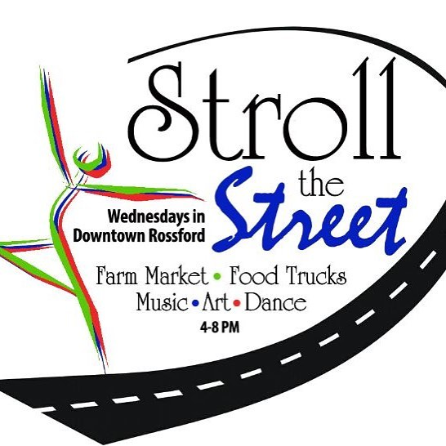
From June 26th through October 9th – Dixie Highway, Rt. 65, in Downtown Rossford will be filled with fun on Wednesdays from 4 to 8 PM. Stroll the Street will feature a Farm Market, Musical and Art Entertainment, Food Trucks and more! It will span one side of the Downtown Boulevard from Ford Memorial Park, adjacent to IPS Corporate Headquarters, through the Downtown.

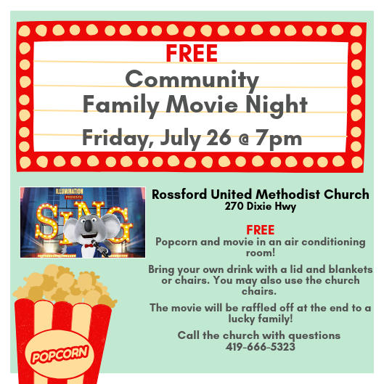

Rossford United Methodist Church

Phone: (419)666-5323 Office Hours: M-F 8:15am-2:15pm Facebook: www.facebook.com/RossfordUMC

Services: 9:00 am Sunday School and 10:30am Worship

E-Mail: rossfordumc@yahoo.com Visit us our website: www.rossfordumc.org

Staff

Pastor: Pastor Dwayne Shugert
Ministers: Every Member
Children’s Ministry: Kim Weyandt
Youth Ministry: Terri Seibold
Secretary: Jenny Graffius
Music Program Director: Sarah Buehrer
Organist: JeanE Waggoner
Custodians: Steve Agler
Jenny Riehm
Nursery: Carol Kotecki
Emilie Fisher

Lay Leadership

Lay Leader: Tom Ridenour
Head Usher: Bob Baughman

