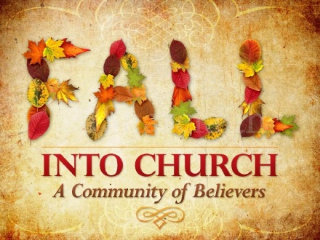

Rossford

United Methodist Church
Our Mission:
"To Know Christ And to Make Christ Known"

In an episode of Doctor Who, and I will readily admit that I am not a huge Doctor Who fan, entitled "Vincent and the Doctor" there is a scene at the museum where the curator talks to the Doctor about Vincent Van Gogh. It is a beautiful scene and every time I watch it, it brings tears to my eyes. The curator says this about Van Gogh, "He transformed the pain of his tormented life into ecstatic beauty."

Vincent Van Gogh turned the pain of his tormented life into ecstatic beauty. To me this is the perfect description of what Christ did on the cross. Jesus took the pain of one of the most barbaric and cruel ways of execution, the cross, and turned that pain into the ecstatic beauty of forgiveness, redemption, hope, and of course, love. The cross stands as that moment in which pain and suffering is turned into beauty and hope. Or as N. T. Wright, one of the greatest Theologians alive today, wrote in his book, Evil and the Justice of God:

"Jesus on the cross towers over the whole scene as Israel in person, as YHWH in person, as the point where the evil of the world does all that it can and where the Creator of the world does all that he can. Jesus suffers the full consequences of evil: evil from the political, social, cultural, personal, moral, religious and spiritual angles all rolled into one; evil in the downward spiral hurtling toward the pit of destruction and despair. And he does so precisely as the act of redemption, of taking that downward fall and exhausting it, so that there may be new creation, new covenant, forgiveness, freedom and hope."

Jesus exhausts the evil of the cross and replaces it with hope and forgiveness and redemption and love. So, in our own times of struggle and pain and suffering, we too join Christ (and Van Gogh) into transforming that pain into the beauty of being a follower of Christ. Knowing that we are not alone, knowing that God is with us and for us, knowing that no feeling is final, knowing that love always wins, knowing that Christ has exhausted evil on the cross he bore.

For the next four weeks during worship we will be looking closer at some of the great works of art by Vincent Van Gogh. Here is the coming schedule for Sunday morning worship:

10/8 - "The Potato Eaters"
1 John 2:1-8
10/15 - "Eternity's Gate"
Colossians 1:15-23
10/22 - "Still Life With Open Bible"
2 Timothy 3:10-17
10/29 - "Starry Night"
Matthew 5:13-16

Continued on Page 2

Rossford United Methodist Church

270 Dixie Hwy

Rossford, OH 43460

Phone:

(419) 666-5323

Office Hours:

M-F 8:00am-2:00pm

Facebook:

www.facebook.com/RossfordUMC

E-Mail:

rossfordumc@yahoo.com

Visit us online at:
www.rossfordumc.org

Services

9:00 am Sunday School

10:30am Worship

Inside This Issue:

Pastor's Message 1 & 2

Worship and DOCK 2

Hospitality/Fellowship 3

Celebrations and
Fundraising 4

Calendar 5

Continued from page 1

Van Gogh at one point in his life wanted to be a priest, and throughout his life he remained a follower of Jesus. This is how Vincent Van Gogh and his use of color is described in Skye Jethani's book The Divine Commodity: Discovering a Faith Beyond Consumer Christianity:

"Vincent wanted to express ideas in his paintings such as hope, love, and grief. He sought to make these invisible realities visible through color. He understood the way colors could trigger different emotions, how each one carried its own personality. Vincent saw red as passionate and dangerous. Blue he associated with the mysterious and the infinite. But the color Vincent preferred most of all was yellow. As the brightest hue on the color wheel, it arrests the eye. Van Gogh recognized something divine about yellow's loud magnetism. As the eye is drawn to the vivid warmth of golden light, so the heart is drawn to the radiant warmth of God's love. He used the color to represent sacred love in many of his compositions, and to Vincent yellow symbolized the presence of the rayon d'en haut - French for 'the ray of light from above'. "

Invite someone you know to join us as we study the art of one of the greatest masters the world has ever known and in the midst of that art, we will see and experience the handiwork of God Himself.
Know today and every day, that you are loved!

Grace and Peace,
Pastor Dwayne

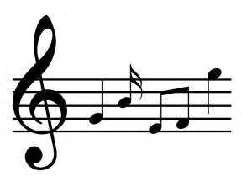

Worship News

The Worship Committee met with Pastor Dwayne on Aug. 22 to introduce ourselves to him and plan for early Fall. We look forward to October and the newest series Pastor will be doing about Vincent Van Gogh, his artwork, and the conflicts he had with his Christianity. Will we learn as much as we did about the ancient struggles of Jonah and how they aren’t so different as ours today?

October 1 – Worldwide Communion Sunday – Come experience a new way to celebrate communion as we share with our brothers and sisters around the world.
October 8 - Regular Worship - Boy Scouts selling popcorn after services.
October 15 - Regular Worship
October 22 - Regular Worship
October 29 – Youth Led Sunday

With Love,
Cheryl Garlow and Nancy Rust
Co-Chairpersons of Worship Committee

HYMN SUGGESTIONS
If you have a favorite hymn and would like it to be considered for future services, let us know. There are slips of paper and a basket to place them in located in the Narthex

DOCK News

I saw Jesus at VBS on September 10th!!! He was in the smiles of the little ones throwing water balloons. He was in the hands of the youth as they helped the little ones play. He was in the feet of all those running and jumping and dancing. He was in the hearts of all the teachers as they were sharing God’s love. He was all over the place. What a fun day we had helping out. We had a little water balloon fun ourselves.

Here’s what’s up for our youth in October:

Oct. 1: We will be running the drive thru for the chicken bbq. We’ll have pizza afterward. There will be NO DOCK meeting that night.

Oct. 8, 15, 22: We will have our regular D.O.C.K. meeting from 5 – 7. We’ll be talking about how our words matter. We’ll talk about taking the KUT test before we speak: *is it KIND? *is it USEFUL? *is it TRUE? If not ZIP IT! We’ll also be prepping for our Oct. 29th worship service.

Oct. 28: We’ll be building our float for the Rossford parade. The theme is “Wild Wild West”.

Oct. 29: We start the day with our youth service and then head over to the marina for the parade. It’ll be a fun day. NO D.O.C.K. meeting that night.

It’ll be a fun and busy month.

Terri Seibold
Director of Youth Ministry
Disciples Of Christ’s Kingdom!

Page 2

Hospitality

Welcome to fall everyone!!

With record heat today it feels like July 24th not September 24th!! But, God has a plan and He is in control. When it's cold out we’ll remember today!

Hospitality has been just flowing along and we don’t need to meet each month. However, I’d like to call a meeting Sunday, Nov. 5th right after church to address and sign Veterans day cards to the vets at the VA hospital in Ann Arbor. We’ll do this again the first part of December for Christmas cards. Reminders in the weekly bulletin.

Thank you to Mary Hill for updating the Little Lambs bags for young kids during church.

Thank you to Kathy Slomski for sending out the weekly bulletins to our shut in list. If you know of someone that would enjoy this ministry please let Jenny in the office know.

Fellowship

October 6th is the pallet painting class at 6 pm. Lots of people have asked if you need art experience. None is necessary and the pallet people are so helpful. The cost is $35 with $10 of that going to next year's VBS. You must sign up and pay by Sept 29th. If anyone needs help with this please contact myself or Kim Weyandt and we’ll be more than glad to walk you through the process. Come out for a fun night!!

Our next craft night will be Tues Oct. 24th 6 -9 pm in the parlor. Another relaxing time to craft and enjoy each other’s company.

It's hard to believe that 3 months from today is Christmas Eve. Let us enjoy this fall season as things get busy around RUMC!!

October greeter and valet Christy and Matt Foster
November greeter and valet Kristen Vargo and Al Weis

In Christ,
Al and Brenda Weis, Hospitality co-chairs
Kim Weyandt and Brenda Weis, Fellowship co-chairs

Ushers and Greeters

Please see Bob Baughman to Usher or Brenda and Al Weis to Greet or Valet.

Helping Hands of St. Louis

Please stay tuned for more information. Our next date is October 19th. Questions please contact Jerry Baumgartner at 419-666-7236.

Prayer Quilts

If you know of anyone who would benefit from a prayer quilt please call or see Nancy Stonerock.
She can be reached at
419-874-3504.

UMC Market

The United Methodist Church has started a "market." This is a way for our church to earn money. You need to go online to www.umcmarket.org and sign up. Whenever you order from this site our church receives a % of what you purchase. There are 89 pages of participating stores and the amount we receive varies. Any questions, see Sue Perkins.

Box Tops and Stamps

We are still collecting Box Tops for Education and cancelled postage stamps. The collection box is located in the Narthex. Please see Barb Chesson if you have any questions.

Can Drive

We would like to remind you that we are still collecting aluminum cans to raise money for our church. If you have any to donate, the container is outside the kitchen door. If you need a pickup, please call Doug Williams at 419-661-9484.

Kroger Rewards
Program

The Kroger Rewards Program is a nationwide program that lets loyalty card holders select charities to which Kroger will donate, based on dollars they spend in stores. If you have a Kroger card, PLEASE check to see that you are signed up so that our church gets a percentage of what you buy. We get a check quarterly from Kroger.
Our Kroger Plus Rewards Organization
# 84283

Page 3

OCTOBER CELEBRATIONS

Anniversaries

John and Bethany Rust 10/2

Jim and Judy Sikorski 10/20

Birthdays

Betty Woods 10/1
Paul Pertner 10/6
Nancy Stonerock 10/6
Dave Olwick 10/8
Jack Engwert 10/12
Debbie James 10/12
Sarah Buehrer 10/13
Kim Weyandt 10/27
Lindsay Brant 10/30
Wendell James 10/30

Fundraising
Calendar
2017

Volunteers Needed
As you look at these events you realize that they are not a one person project, or even a five person project. So please put these dates on your calendar and plan on helping any time you are able to.

FALL BBQ - Sunday, October 1st - after services
We will sell out quickly.

FALL RUMMAGE SALE - October 19th 9:00am-6:00pm, October 20th 9:00am - 4:00pm, and October 21st 9:00am - 12 noon (also bag day!)

CRAFT BAZAAR - November 4th - See Kim Weyandt with questions.

CHRISTMAS STORY SHOW - Sunday, November 19th
A new fundraiser more info to come

"LET IT GLO" - Christmas Tree and wreath decorating contest. December 1st and 2nd. Another new fundraiser. More information to come

Please put these dates on your calendar and plan on helping in any way you are able.

Thank you!
Sue Perkins
Chairperson

UPDATE ON PILKINGTON RAILROAD CROSSING CONSTRUCTION
This work has been reschedule to begin on Oct 9th. Rt. 65 will be closed in both directions for approx. 10 days while a new RR crossing is put in place. Detour routes are I-75 to Buck to Lime City to Rt. 65.

CHICKEN BBQ
Sunday, October 1st, 2017
12 noon until sold out

Menu
½ chicken
scalloped potatoes
sweet and sour cabbage
green beans/bread/dessert

EAT IN OR DRIVE THROUGH

Meeting Night for October

Tuesday - October 10th, 2017
6:30 pm SPRC
6:30pm Trustees and Finance
7:30pm Admin

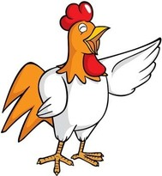

Page 4

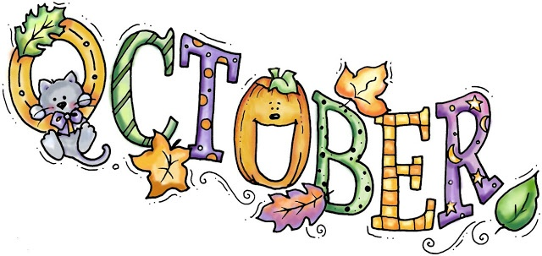

Sun. | Mon. | Tue. | Wed. | Thu. | Fri. | Sat.
1 | 2 | 3 | 4 | 5 | 6 | 7
9:00am Sunday School  10:00am Worship with communion  Chicken BBQ | 4pm - 7pm  ESL Class -Upstairs | 9:15am Ladies Bible Study  4pm - 7pm  ESL Class -Upstairs |  |  | 6-10pm Pallet Painting
8 | 9 | 10 | 11 | 12 | 13 | 14
9:00am Sunday School  10:30am Worship  Boy Scouts  Popcorn sale  after services | 4pm - 7pm  ESL Class -Upstairs | 9:15am Ladies Bible Study  4pm - 7pm  ESL Class -Upstairs  6:30pm Cub Scouts  6:30pm Finance, Trustees, SPRC  7:30pm Admin  RUMMAGE SALE SET UP - FLC/Narthex/Parlor | 6:30pm Boy Scouts | 7:00pm Choir 8:30pm AA |  | 9:00am Men's Breakfast @ Silver Moon  No Contra Dance
15 | 16 | 17 | 18 | 19 | 20 | 21
9:00am Sunday School  10:30am Worship  5:00 pm DOCK  RUMMAGE SALE SET UP - FLC/Narthex/Parlor | 4pm - 7pm  ESL Class -Upstairs  Fall Leaf Pickup begins | 9:15am Ladies Bible Study  4pm - 7pm  ESL Class -Upstairs  6:30pm Cub Scouts | 6:30pm Boy Scouts | 7:00pm Choir 8:30pm AA  RUMMAGE SALE  9am - 6pm | RUMMAGE SALE  9am - 4pm | RUMMAGE SALE  9am - 12pm
22 | 23 | 24 | 25 | 26 | 27 | 28
9:00am Sunday School  10:30am Worship 5:00pm DOCK | 4pm - 7pm  ESL Class -Upstairs | 9:15am Ladies Bible Study  4pm - 7pm  ESL Class -Upstairs  6:30pm Cub Scouts | 6:30pm Boy Scouts | 7:00pm Choir 8:30pm AA
29 | 30 | 31
9:00am Sunday School  10:30am  Youth Led Worship  No DOCK  2:00 pm Halloween Parade | 4pm - 7pm  ESL Class -Upstairs  6:30 - 9:30pm  Choraliers  Practice (parlor) | 9:15am Ladies Bible Study  4pm - 7pm  ESL Class -Upstairs |  |  | Reserve your event today!  Contact Jenny at  419-666-5323

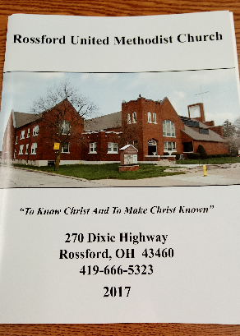

Thank you for your patience while waiting for our new photo directory to be finished. It is finally done! Each family that sat for pictures in May will receive a complementary photo directory. Those that did not, can still obtain a directory but it is on first come first serve basis. This year we’ve added a smart device app that will accompany the photo directory. It is eligible for download on a iPhone or Android device for FREE!!!! After downloading the app, you will need to contact the office for your unique identifier code that will allow you access to the RUMC church directory app. You may have already been sent one via email. Check your spam folder. These codes are case sensitive.

iPhone: iOS (Apple App Store)

- Download the App
- Go to the App Store and search for ‘universal church directory’
- Click on the “GET” button
- The button will then change to “INSTALL,” click on the button again
- When the App has finished installing, click “OPEN”
- After App Installation
After the user has downloaded and installed the App, once the App is opened, the user will be prompted to enter a code, given to them by their church administrator.
- When the App is accessed for the first time, you must enter your unique identifier code, which is the access code that was emailed to you.
- Click on the “DOWNLOAD MY CHURCH DIRECTORY” button (there may be a few seconds delay)

Android (Google Play Store)

- Download the App
The first thing a user needs to do is actually get the App onto their mobile device. This section lists, in bullet format how that will work and any concerns/questions related to this part of the user experience.
- Go to the Google Play store and search for ‘universal church directory’
- Click “INSTALL” to download and install the App
  - This will display a popup window, in which you should select the “ACCEPT” button
- When the App is finished installing, click the “OPEN” button
- After App Installation
After the user has downloaded and installed the App, once the App is opened, the user will be prompted to enter a code, given to them by their church administrator.
- When the App is accessed for the first time, you must enter your unique identifier code*

Using the App
There are two options once you’ve entered your identifier code:

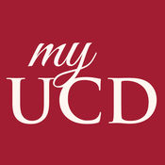
- List View
Browse your church directory using a list of names
- Image View
Browse your church directory using family pictures
- Settings
If the settings option is chosen, the App will resort back to the main screen, with a prompt for an identifier code. This is the only settings option throughout the App.

NON-PROFIT
US POSTAGE
PAID
TOLEDO, OH
PERMIT #522
ROSSFORD UNITED METHODIST CHURCH
270 DIXIE HWY
ROSSFORD, OH 43460

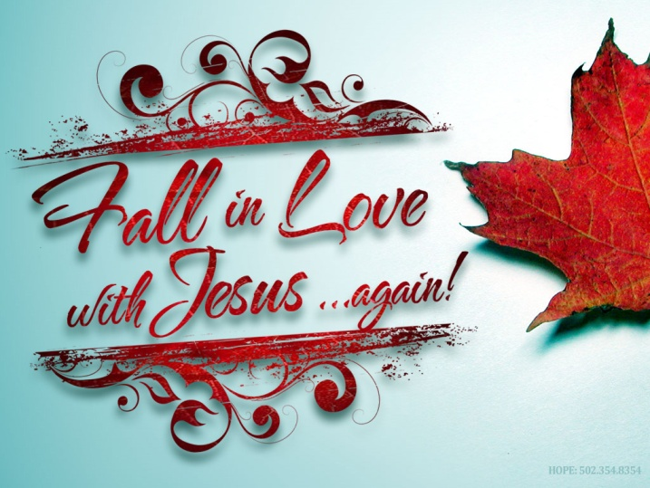

Staff

Pastor: Pastor Dwayne Shugert
Ministers: Every Member
Children’s Ministry: Kim Weyandt
Youth Ministry: Terri Seibold
Secretary: Jenny Graffius
Music Program Director: Sarah Buehrer
Organist: JeanE Waggoner
Custodians: Steve Agler
Jenny Riehm
Nursery: Carol Kotecki
MacKenzie Rodriguez

Lay Leadership

Lay Leader: Tom Ridenour
Head Usher: Bob Baughman
Media Directors: Troy Westfall
Jeff Comley

